**AI- Scribe Sample Architecture:**

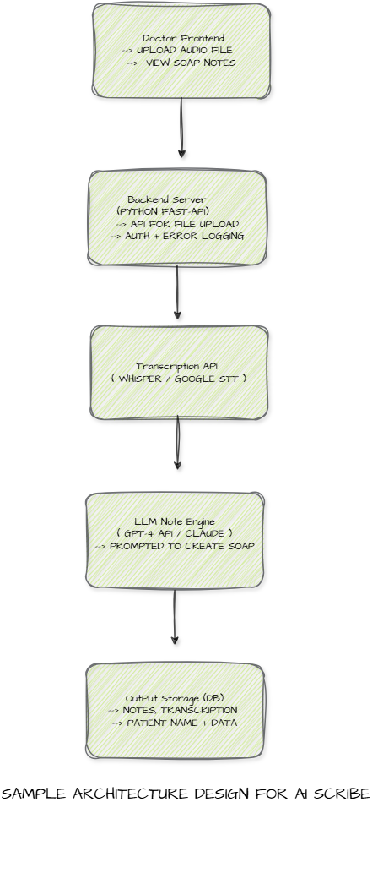

**AI- Scribe Roadmap:**

Step 1: Planning & Setup:

* Define scope: Focus on recording doctor speech, transcribing it, and generating SOAP notes using an LLM.
* Set up development environment: Git repo, cloud services (e.g., AWS/GCP), choose tech stack.
* Prepare sample GI/obesity consultation audio/text data.

Step 2: Transcription Module

* Use OpenAI Whisper or Google Speech-to-Text API.
* Test with a few short clinical audio recordings.
* Output plain text from voice reliably.

Step 3: AI Note Generator

* Build prompt templates for SOAP note generation.
* Connect transcription output to GPT-4 or Claude to convert into structured SOAP format.
* Ensure medical terminology is retained.

Step 4: Minimal Web UI

* Build a simple frontend using React:
* Upload audio file.
* Display transcription.
* Show AI-generated SOAP note.

Step 5: Integration & Testing

* Connect frontend to backend via API (FastAPI or Flask).
* Run E2E tests with 3–4 real-world consultation recordings.
* Validate note quality and accuracy.

Step 6: Polish & Security

* Add basic authentication (email/password).
* Implement data encryption at rest and in transit.

Step 7: Demo & Feedback

* Conduct demo with target doctors or stakeholders.
* Collect feedback.
* Log bugs or issues for future sprints.